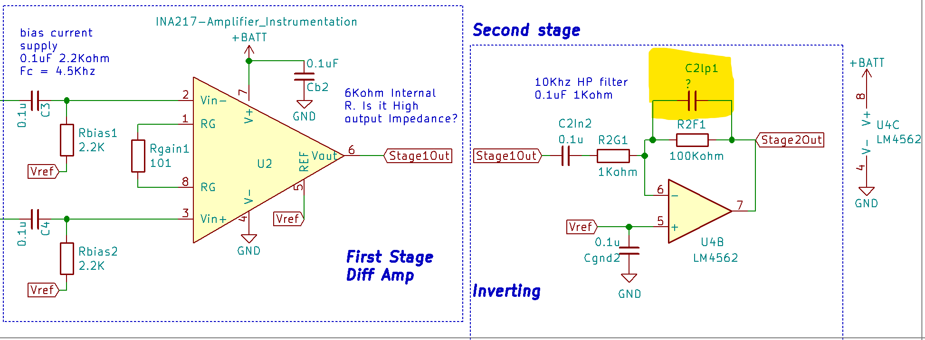

The first waveform is without C2lp1 cap

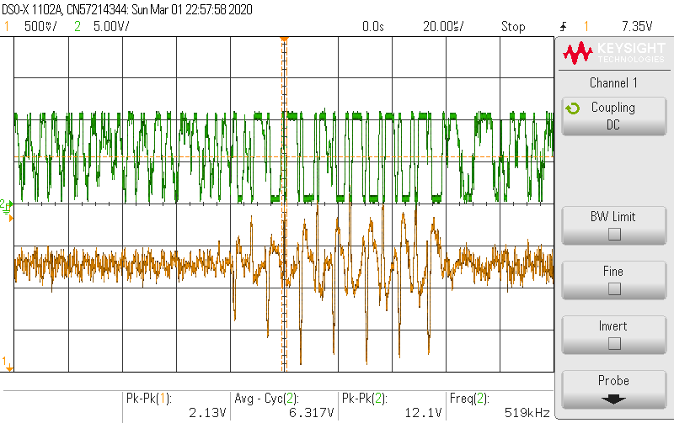

Orange: first stage output,

Green: second stage output.

The signal is still noticeable as they are fully saturated. But only to human eyes.

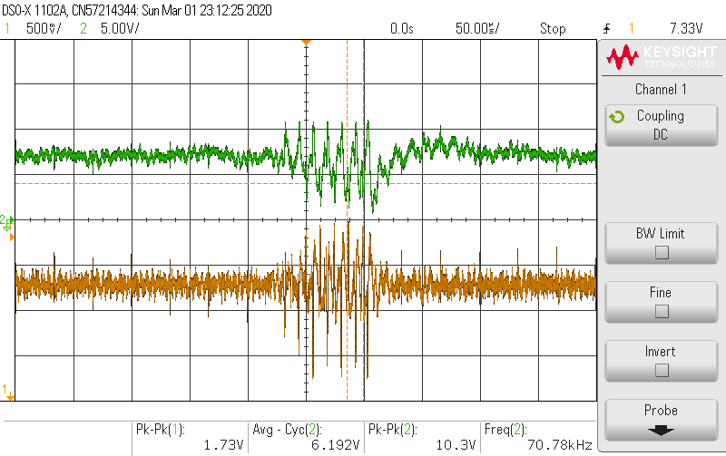

With C2lp1 = 100pF.

The noise is suppressed (not much), but the output signal is also suppressed by 10 times. (suppose to be 100 times gain).